Fundamentals and Development of Self-Driving Cars

Yoganandhan A 1, Subhash S D 2, Hebinson Jothi 3

Department of Mechatronics Engineering, Chennai Institute of Technology, India

[praviinvj@gmail.com](mailto:praviinvj@gmail.com) , [subhashsd73@gmail.com](mailto:subhashsd73@gmail.com) , [hebinson007@gmail.com](mailto:hebinson007@gmail.com)

**Abstract** – This paper represents detailed information on the constitutional and development of self-driving cars. For a decade, in the automotive industry, there are lots of malfunctions are performed.  It makes many issues like accidents, driver’s liability and much more.  These kinds of problems arise when human interfaces with the car.    In real-time Self-driving cars that are driven by digital technologies without using a human interruption. Based on the fundamentals of developing self-driving cars are totally by sensing their environment and automating the tasks.  In our proposed system the Localization, Perception, Prediction, Planning, and Control are to make define and governing the car, certain algorithms are used to control the autonomous system and are used for steering functions. The autonomous car can predict and cruise its path and traffic signs as like as pedestrians. It can minimize accidents, fuel rates, and parking space.

**Keywords** – *Driving assistance system, Fundamentals of autonomous car, Introduction to Self-driving cars, Localization, Perception, Intelligent autonomous systems, prediction, HD-maps, Controls of self-driving car.*

**Introduction**

The autonomous car is also known as Self-driving systems or driverless cars, a vehicle has an ability to sensing its surroundings and moving with defined lanes without the human approach. Self-driving cars technologies mostly involved in the computer system by automating vehicle control parts. These technological parts possess a range of competencies, from forward-collision warning and antilock brakes to lane-keeping and adaptive drive control, to fully automated driving, Autonomous car combines the variety of sensors, actuators, and cameras. The benefits of self-driving cars are ease to anticipate and manage traffic issues and provide build-up mobility for all users. The basic fundamentals are in High definition maps, Localization, Perception, Prediction, Planning, and Control of vehicle as follows.

**Origin**

The first era of autonomous cars started in the 1920s. There is a lot of development taken place in creating new technology in the later 1960s. The ALV projects were conducted by the Robotics Institute of Carnegie Mellon University Navlab. By 1994, the double robot vehicles called Vita-2 and VaMP of Daimler-Benz and Ernst Dickman’s exposed self-driving in free lanes. In 2004 the DARPA (The Defense Advanced Research Projects Agency) conducted the test, were self-driving cars complete the course, but no one did that. In 2005 the second challenge was conducted, in that Sebastian Thrun led his team and completed the course. The efficient self-driving car technology was developed by Google in Toyota Prius and it also licensed by the Department of Motor Vehicles in 2012.

**Levels of Automation**

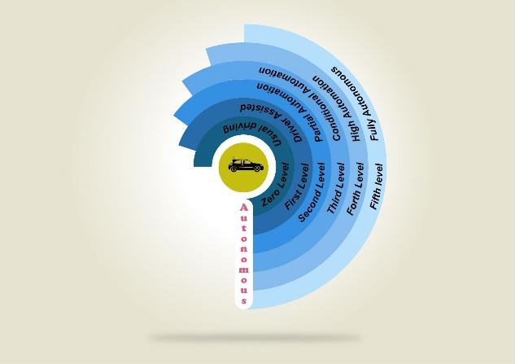

*Fig: Five Levels of Automation*

There are five levels of automation systems that enhanced the self-driving system. The zero automation is a base level automation system it was a soul decision matter Human driving system. The First level is driver support, some intelligent aspects were included in it, and the driver was semi-engaged. The Second level of automation is limited automatic cruise control and Automatic lane-keeping system. The Third level is conditional automation; Human interface is needed whenever necessary. The Fourth level is High-level automation, there is no human interface. The Fifth level is a fully autonomous Vehicle that no human and his interface is not needed.

**High-Definition Maps**

The High-Definition maps are not like Normal maps or navigation maps. The HD maps are more important for self-driving cars. They have a higher level of accuracy of objects, lanes, and locations up to 10cm. It contains a huge amount of driver assistance information, Three-dimensional representation of road network, layouts intersection, and location of the signboards. It helps to solve the localization problem, figuring out exactly where the car is around the world. It also recognizes the shape of objects. HD maps are a core of self-driving cars.

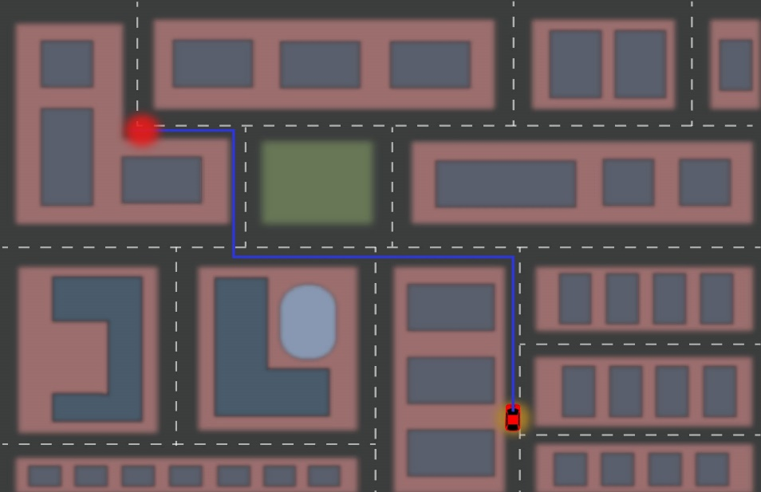

The preprocessing and coordinate transformation need to collect data and compare it with HD maps. The uniform coordination system is used in most vehicles. The ***Region of Interest***, the purpose of this section is to build a program that can easily identify the lanes separately in a picture or a video frame from the camera. In that, we have to convert this image into a grayscale that processes a single channel much faster than three channels RGB and less computation intense. Planning with maps makes planners identify possible routing options. The Maps are also containing information related to the source of data which sensor was used to get the information when the map was last updated.

**Localization**

Localization means that shows the exact location of the car. The sensor and the maps are collecting the data to find an exact location. It also mentions our car in current position on the maps.

**A) GNSS-RTK**

The GNSS is known as the ***Global Navigation* *Satellite System****,* there are 30 GPS satellites operating in the outer space each Satellite were located on 20,000 kilometers away from the Earth’s surface. The control system is specified around the earth for controlling satellites.

The RTK is called a ***Real-Time Kinematic*** positioning system is also a satellite navigation system used to exact position data from a satellite-based system. But the RTK based system was having issues with tall buildings. It was also low-frequency updates like 10MHz. The GPS that equipped in the car can update its location in 0.1 seconds.

**B) Inertial Navigation**

An Inertial navigation system is navigational equipment that uses a Computational device, Motion sensors (Accelerometers) and Rotational sensors (Gyroscopes).

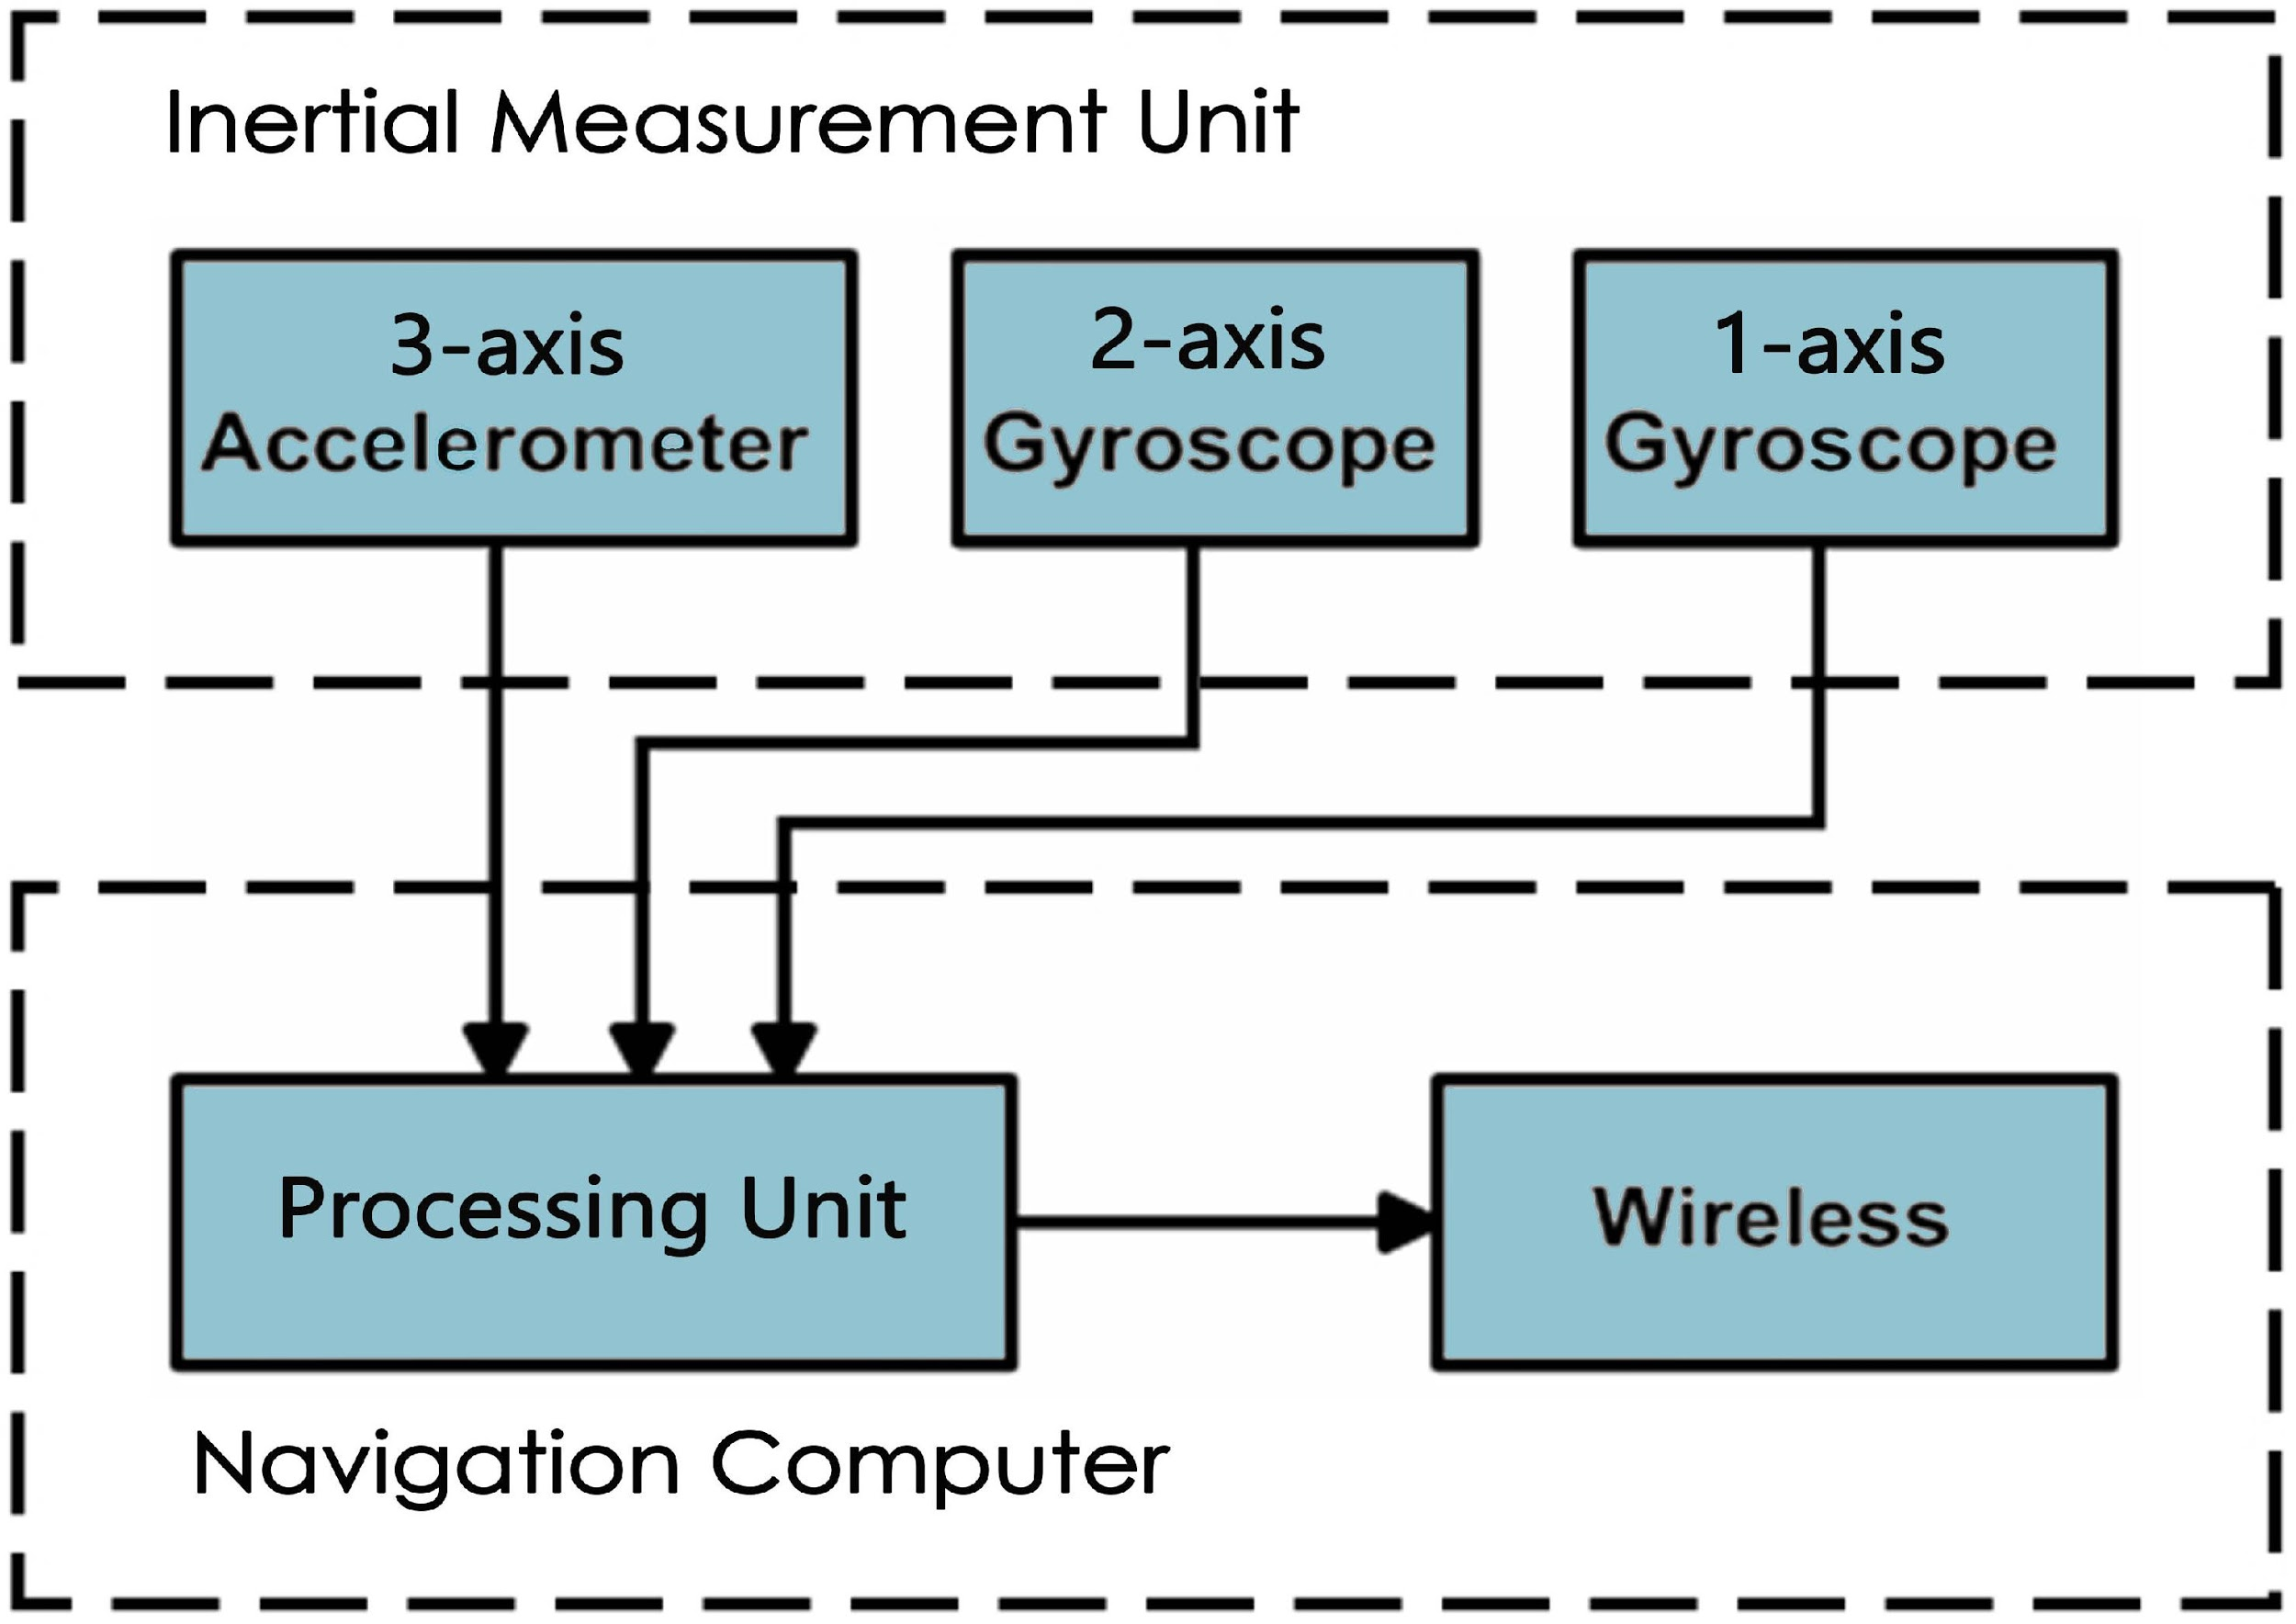

*Fig 2.1: Inertial Navigation System*

That can extend to collect the data and the action or process of detect position, orientation and the velocity (direction and speed of movement of vehicles)

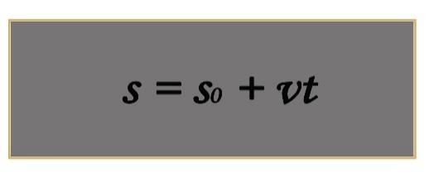

**S0 = Initial Location**

**V = Velocity**

**T = Time Taken**

We are using a 3-axis accelerometer to define the acceleration of the car at any point of the time and also measure the velocity of the current position. Gyroscopes are used to measure the relative position of the spin axis and the three external Gimbals to measure ***Initial Measurement Unit***(IMU).

**C) LIDAR Localization**

LIDAR (**L**ight **I**ndication **D**etection and **R**anging) this sensor is used in self-driving cars for detecting and collecting data from the environment in 3D point clouds. This method continuously matches and exposes the data from the Lidar sensor with HD maps. There are many algorithms that are done to test the point of clouds. ***Iterative Closet Point*** (ICP) is the first approach, filter algorithms are another approach of Lidar localization.

**The Kalman Filter** method is used to find and assume the current position of the car by detecting using sensors and also get by the movement of the car based on the acceleration of the vehicle.

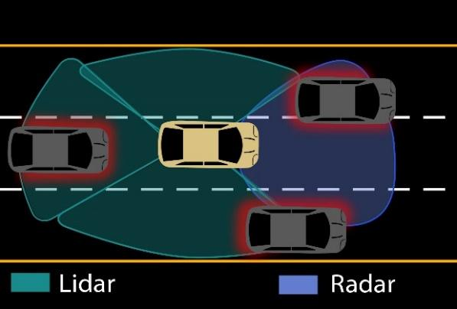

*Fig 2.2: Lidar and Radar Detection system*

An extended ***Kalman filter*** algorithm is to possess by getting 3D point Cloud data across ***Gaussian*** ***mixture*** in an exact number of times in solution-maps. This algorithm was proposed, when there are numerous autonomous cars that were detected in terrible weather conditions and where the localization evaluated errors of around 15 cm.

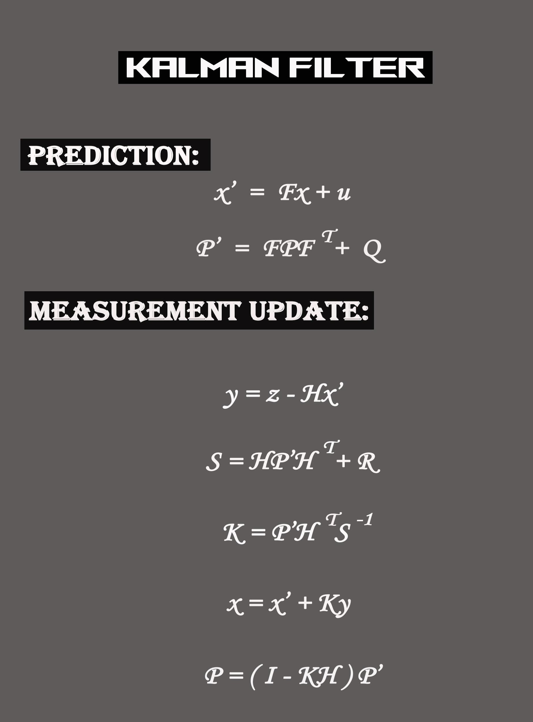

*Fig 2.3: Kalman Filter for 3d Point Clouds*

In a statistical method of the control system, the Kalman filtering is also called Linear ***Quadratic* *Estimation*** (LQE), in This we use a series of analysis attending over a period of time, and contains other deception and unspecified variables.

**D) Camera-Based Localization**

In camera-based localization driverless cars are used to estimate the current location of the car and relates to the map. A ***Recursive Bayesian*** filter algorithm is used to find intervention in a graph by manipulating its framework and the model of how the car displaces, as measured by the travel distance of the car.

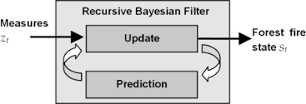

*Fig 2.4: Recursive Bayesian Filter for interferences in graph models*

This filter is able to mark out the car’s position in the graph plot and increase the possibility that the current position lies in a point graph that interferes with the recent car’s displacements.

**Perception**

Perception is a tough task in controls of self-driving cars. The perception module has been upgraded completely to handle the comprehensive and fusion of sensors.

The **Perception** module incorporated the ability to use Multiple Cameras, Radars, and Lidar to recognize obstacles and fuse to their individual tracks to obtain in the final track list from the controller. The obstacle, sub-module detects, classifies and tracks obstacles. The sub-modules are also predicted obstacle motion and position information. For lane-keeping, we had lane instances by post-processing lane parsing pixels and calculate the lane relative location to the vehicle [9].

The core concepts of self-driving cars are Detection, Classification, Tracking, and Segmentation. ***Detection*** is the means of detecting the object that capture images by cameras or the Lidar inputs. ***Classification*** is a process done by some Neural Network algorithms and classifies in certain manners. Tracking is the means of the tracks that the objects from the car like and their velocity, distance, and some other aspects. The ***Segmentation*** in the means of clarifies each pixel form the camera images and semantic category.

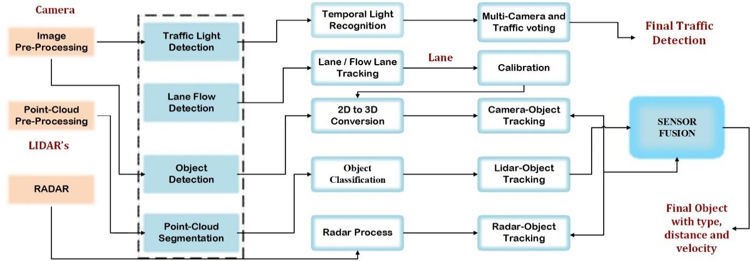

*Fig 3.1: Flow Chart of Perception*

**A) Camera Images**

The camera images are the common data; the images are comprised of pixels. Which are called small units of color, in every pixel of an image, is just a numerical value, where the values are comprised into an image matrix.

Color Images are more complex. Color images are constructed as Three-Dimensional cubes of values each cube is a Height, Width and the Depth of the value.

**B) LIDAR Images**

The Lidar images are getting from the sensor which creates the point cloud on the environment and defines the objects around it. The Lidar works by the laser coming out of it and getting back with the modified frequency that makes it measure distance.

**C) Machine Learning**

Machine Learning is extremely used to find out the solution to distinct problems that appear in the construction of driverless cars. With the insertion of sensor data proceedings an ***Electronic Control Unit***(ECU) in a car, it’s fundamental to enhance the application of machine learning to carry out new tasks.

The ***Supervised Algorithms*** make practicing data to learn and they endure to gain till they get to the equate of determination and they strive to reduce the possible error. Supervised learning is also classified into Regression, Classification, and disclosure or dimension contraction.

***Unsupervised******Algorithms*** are another lay of algorithms that land between supervised and unsupervised. There is an objective label in supervised learning; there are no defined labels in unsupervised learning, the ***Reinforcement******learning*** subsist of time-delayed and inadequate characterize for future rewards.

***Regression*** is also a kind of algorithm for anticipating functions. The Regression Analysis figures out the relationship between two or more reliant variables to collate the effects of independent variables on specific scales and it commutes mostly by the metrics.

**Neural Networks**

An Artificial Neural Network is used to learn and solve complex patterns of data. Neural Network is comprised of a large number of neurons. For Neural Networks the most basic depiction of the image is “The Pixel amount of the Image”.

**A**) **Back Propagation**

The learning is also called Training. It was consisting of the step cycle.

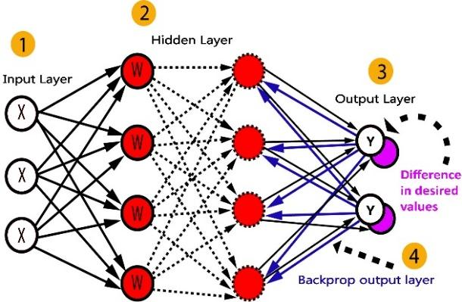

*Fig 3.2: Back Propagation for Error Reduction*

**Feed Forward** – Feed each image to Neural Network (n, n) to generate the output value.

**Error Management** – The difference between Ground Truth and generated output value.

**Back Propagation** – We sent the error to back position through the Neural Network feed to forward on the reverse.

**B) Convolutional Neural Network**

The Convolutional Neural Network is a perfect solution to the Perception problem. The input values for CNN are multi-dimensional values, including two, and three-dimensional shapes that define most of the sensor data.

**C)** **Region-Based Convolutional Network**

The Region-based Convolutional Network (RNN) gets the finest object detection efficiency by the deep convolutional network to arrange the object’s outline. But R-CNN has notable defects.

**1.** **Training is a multi-stage pipeline**

R-CNN is the work to fine-tune the ConvNet on object proposals using log loss. Then, it fits ***Support Vector* *Machines*** (SVM) to Convolutional Network features.

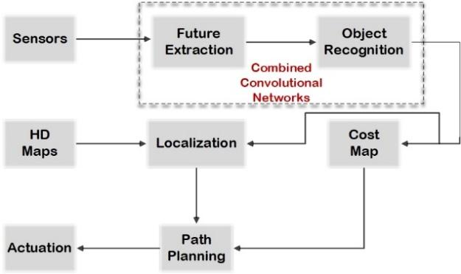

*Fig 3.3: Combined convolutional Networks*

**2. Training is expensive in space and time**

For Support Vector Machines the bounding box is the regression training, the feature is extracted from each object proposal in each of the images and written to the output. The deep neural network, such as the OxfordNet, these features require higher Gigabytes of memory and repository.

**3. Object detection is slow**

At last, test-pace that apparencies are derived from each object proposal in each test input, Detection with OxfordNet takes 47s / input on a Graphical Processing Unit.

**D) Tracking**

After detecting the object, it is continuously tracked. Detection of every object, frame, and identification of each of the objects is done with the ***Boundary Box***. If the identity gets the conformation it will match all the objects detected in the previous frame. That object detects in the frame by finding objects with a higher similarity.

1. **Segmentation**

The semantic segmentation involves the classifying of each pixel of the image. ***Fully* *Convolutional Neural Network*** (FNN), in that FNN is replacing the flat layers at the end of a traditional CNN architecture with convolutional layers. The first part of the network is called encoders and fetches on the input image. The second half is a decoder it applies to output.

**F)** **Region of Interest**

The region of interest is based on the object detected by the read-data input from the point-cloud data for certain applications.

1. **Single Shot Detector**

The SSD approach is based on the feed-forward convolutional network that produces a fixed-size collection of ***bounding boxes*** and counts for the presence of the object with the class instances in those boxes, it followed by a non-maximum suppression step to produce the final detections. The Early network layers are based on a standard architecture used for the high-quality image classification technology, which we will call as the base network. We then add the accessory framework to the network to produce detections with the following structures.

***Multi-scale feature maps for detection*,** in that we add convolutional network layers to the end of the base network.

***Convolutional predictors for detection***, in this approach we add extra feature layers that can produce a defined set of detection and predictions by using convolutional networks.

1. **You Only Look Once (YOLO)**

Yolo is a new approach to object detection technology. It was extremely fast when compared to other technology.  Yolo is real-time object detection. It may apply to detect images in multiple locations. If we use a single neural network for an image it may divide the image into many regions and predicts boundary boxes of each region. It can also segment every object in that image using classifiers and filters.

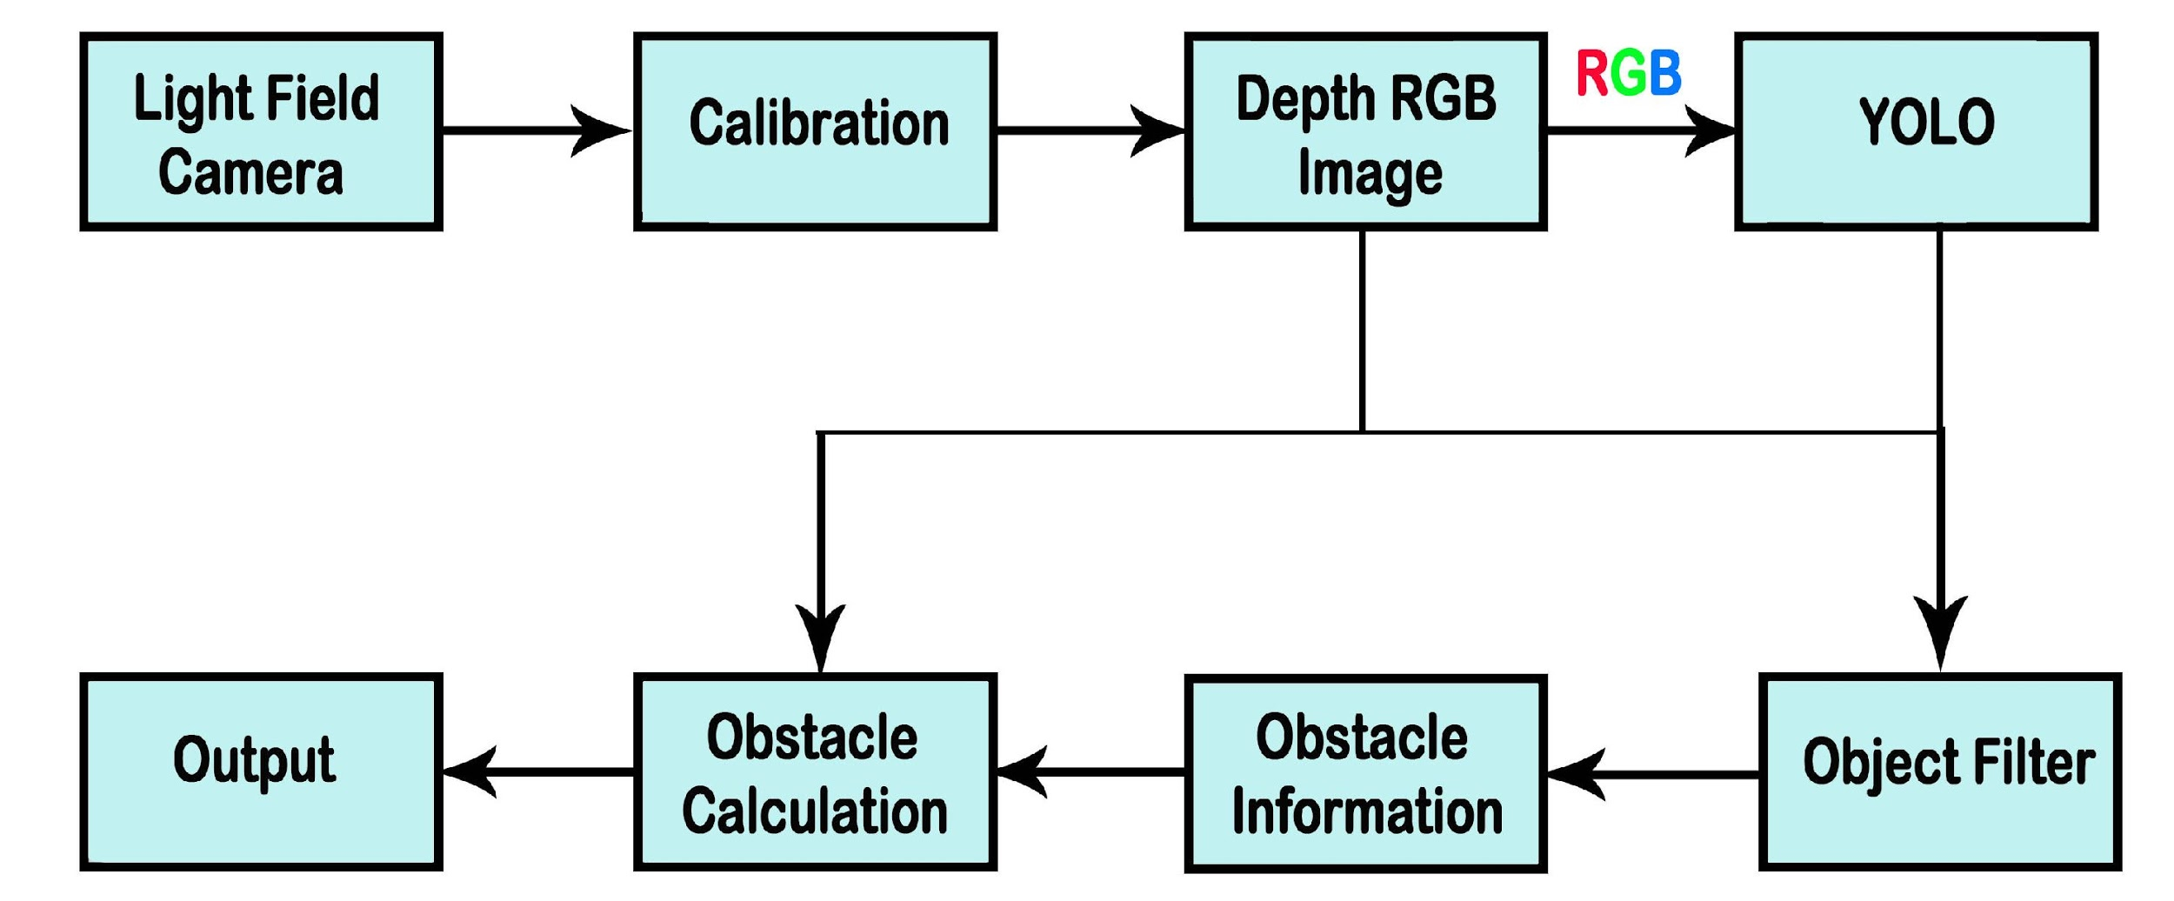

*Fig 3.4: YOLO Object Detection from Images*

**Prediction**

The prediction module studies and predicts the behavior of all the obstacles detected by the perception module. Perception receives obstacle data along with basic perception information including positions, headings, velocities, accelerations, and generates predicted trajectories with probabilities for those obstacles.

Prediction needs to be real-time, latency as small as possible accurate; Predictions are also been valued on learning a new behavior of vehicles.

1. **Model-based Prediction**
2. **Driven-based Prediction**

***Model-Based Prediction***, one model describes the moment of vehicles turning positions. Another model describes the movement of the vehicle whether continuing straight or not.

***Data-Driven Prediction***, it was used by machine learning to train a model based on the observations once the model is trained and able to make predictions in the real world.

**A) Lane Sequence-Based Predictions**

In the lane sequence-based predictions we have to divide the path into multiple segments.

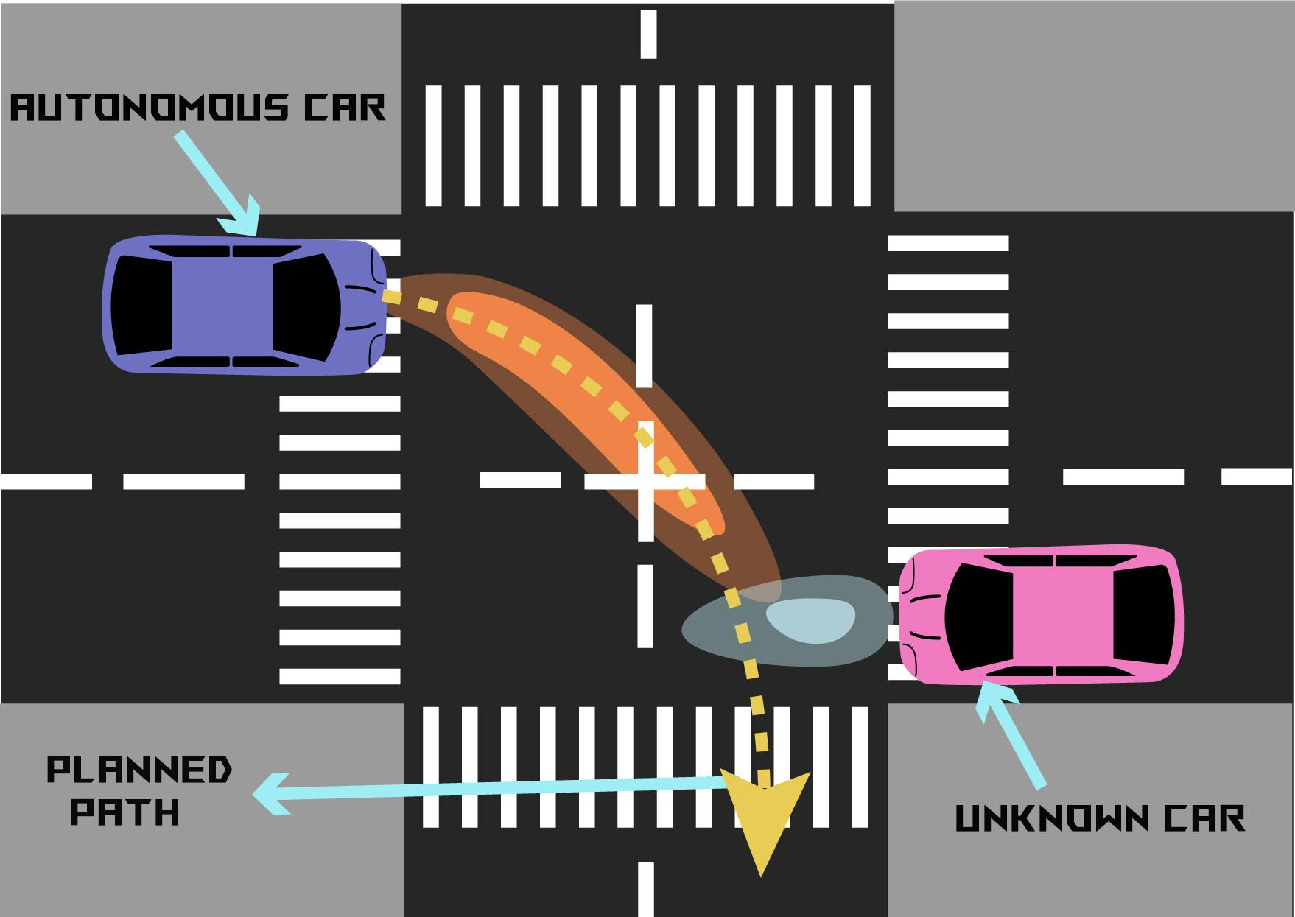

*Fig 4.1: Lame Changing using predictions*

Driverless vehicles are installed with many lead sensors that detect other vehicles, walkers, and interruptions in the environment. If any obstacle status occurs, we have the knowledge to predict the state, we have to know the state of an object .

The classical approach of probabilistic graphical models, such as ***factors graph* *spatiotemporal graphs***, and the dynamic Bayesian networks, which bring graphical models into the sequential modeling space, is widely used in self-driving cars community for many reasons including their interpretability and the high-level structure, which can capture various relationships between features to modeling temporal sequences.

**B) Recurrent Neural Networks**

An approach that takes special advantage of time-series data (Back Propagation) apart from its standalone utility is the recurrent neural network. For larger input, the SSD models provide constituent of the system to handle object detection. In further, we can also detect the video simultaneously by using Recurrent Neural Networks.

**C) Trajectory Generation**

Trajectory planning was a final step of the prediction process. We can be getting constrains that will eliminate most of the candidate trajectories. We make an assumption that the car will align from the center to the target lane.

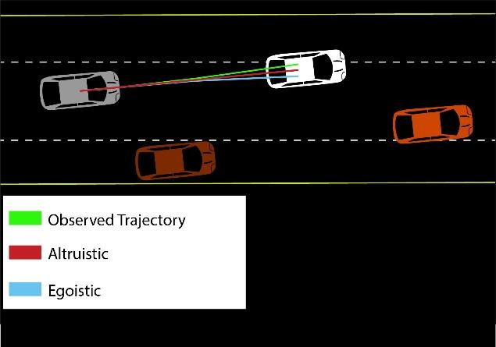

*Fig 4.2: Trajectory Planning to attain the correct path*

In that above figure, Path Planning for self-driving vehicles turns into desirable when technology considers the physical environment in a way that enables it to search for a path. In, simply real-life environment is transferred into a digital composition. The path planning system searches for and detects the lane and passage in which a car can drive [8].

**Planning**

Planning is a base of Routing. The routing takes the map data as input and output a navigable path. Planning is a decision taking task. It was majorly divided into two groups called Path planning and Speed planning. The path planning is also called a path generation. In that case the car would plan its right path and also change the lane without any collision with other vehicles. The speed generation in the means of calculation other vehicles speed and distance and decides the car speed at the same time.

**A) Routing**

Routing was planning to go from starting point to a destination. It needs three inputs

* **Map**
* **Current position on the map**
* **Destination**

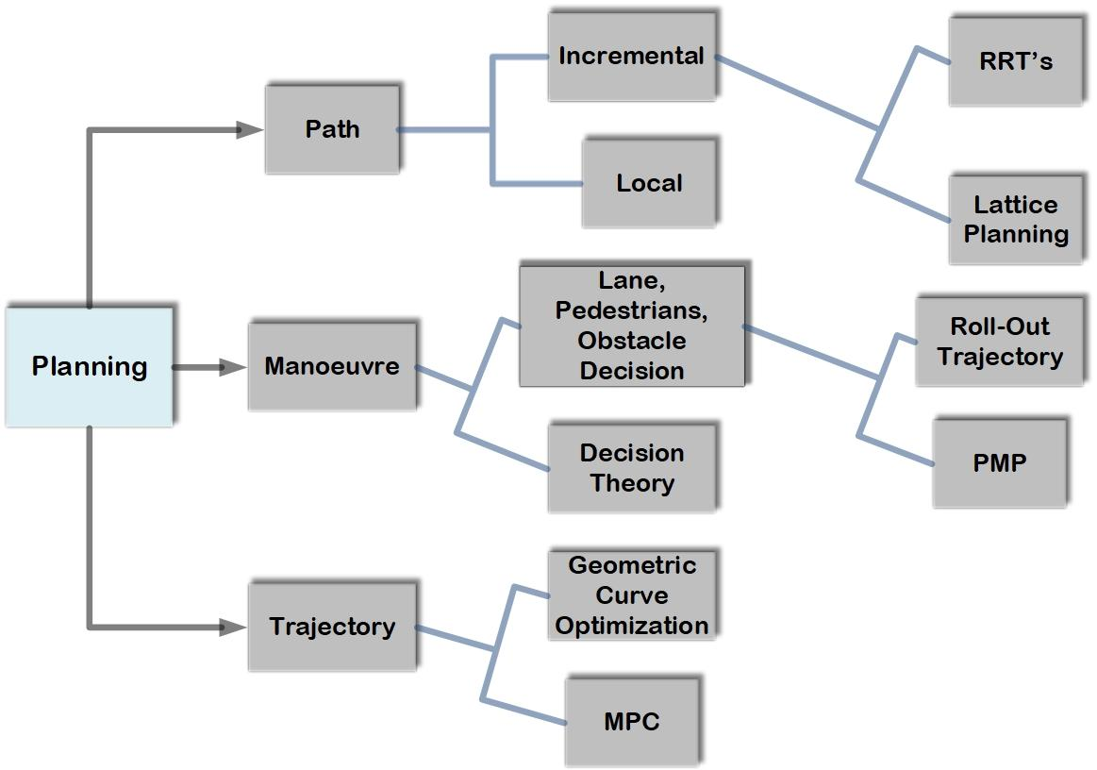

*Fig 5.1: Flow Chart of Planning*

***Route Module*,** Trajectory planning how we make accurate decisions to avoid obstacles and create a smooth ride for the passengers.

**B) Graph Analysis**

The graph is not the state-space graph, in fact, unlike the state-space graph in which a plan is a path through the graph. The planning graph is essentially a flow in the network flow sense. Planning Graph is closer in spirit to the ***Problem Space Graphs*** (PSG).

**Nodes** – Section of Road

**Edges** – Connection between on those sections

***Constraints*,** In the real world it was plenty of constraints, which was a major use of trajectory to a collision-free, obstacle-free passengers make to feel more comfortable.

***Frenet coordinates*,** it helped us to describe the position of cars with respect to the road.

***Trajectory Planning*,** it was the most crucial moment of planning of the car the ***Path-Velocity*** decoupled planning.

1. **Path-Planning 2. Speed-Planning**

**C) Path Generation and Selection**

The path Generation and Selection is the next process after it defines all constraints (Velocity, Lane, Distance); it was based on the position of the car, it also reduces the collision with other cars in lane changing.

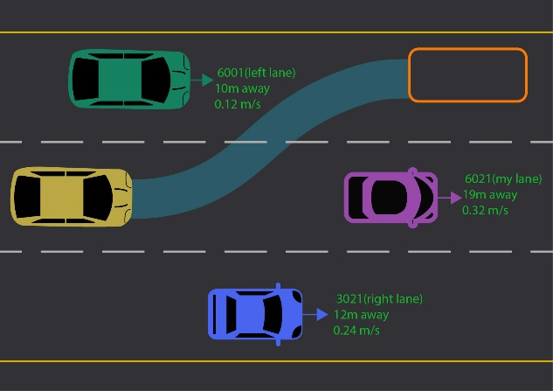

*Fig 5.2: Path Generation to avoid Collison*

**D)** **Lattice Planning**

The trajectory was an implement in 3d representation longitudinal dimension, lateral dimension, time dimension. There are two kinds,

* **SL - Trajectory**
* **ST - Trajectory**

**Controls**

Control is the main strategy of actuating the vehicle to move it towards the road. The control inputs are Steering, Acceleration, and Brake. It is especially for safety as planning and controls the smoothness of driving, it is the main option to control.

1. **PID – Proportional Integral Derivative**
2. **LQR – Linear Quadratic Regulator**
3. **MPC – Model Predictive Control**

**Control Pipeline**

Two input aspects are ***Target*** ***Trajectory*** and ***Vehicle* *state***. The Target Trajectory comes from the planning module. Each point of trajectory as designates position (x, y), velocity (***v****)* and the acceleration of the vehicle (***a***). The car state determines the position by using the localization module. This gets data from the sensor in the steering, acceleration, and brake.

**PID Control**

The important aspect of self-driving vehicles is safety and their competence to adapt various cases and path conditions. We are similarly composing and implementing of such controlling methods, a Proportional-Derivative (PD) controller built within accord with the sensors for controls, a Proportional Integral Derivative (PID) controller as increase the steering control, the controller construct for the more adaptable developmental computational methods.

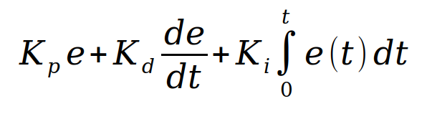

In the above equation that defines the PID controller, where **Kp, Ki, Kd**refers to ***Proportional***, ***Integral***, ***Derivative*** respectively. For utilization in discrete form, the equation is altered by Euler’s for numerical integration. The **ts** refers to sampling time.

**Linear Quadractive Regulator**

In Linear Quadractive Regulator method the constant and time-varying Vehicle Speeds. The latter is implemented by using a simple gain scheduling method at the grid of the operating points.

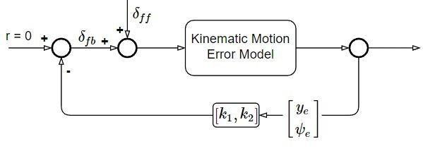

*Fig 6.1: Linear Quadratic Control System*

In the design of stabilizing LQR state space control coefficients (***k1, K2***) for the given linear system and obtain the time-varying controllers are different vehicle speed as (***k1*(*V*(t)), *k2*(*V*(t))**) that can be obtained through the Matlab.

**Model Predictive Control**

The MPC is an advanced method of process control that is used to control a process while satisfying a set of constraints. It can obtain further speedup by solving the planning problem approximately it can also fix boundary parameters.

**Conclusion**

This paper presents detail information about the fundamentals and development and major aspects of self-driving cars.  The framework formulates the problems that arrive from the automotive industries that make major losses. The errors from the industry are non-predictable.  Multiple solutions from the different scenarios make that problem to clear. One of the main aspects is the era of driverless cars is to make the successful experimental results show utility to this approach [1-10].  In recent days many companies involved in research and manufacturing of self-driving cars inefficient methods to solve various problems on certain aspects. In our work, we detailed the real-time self-driving cars and also about every circumstance clearly and also approach it in the right way.  In the future, the different technologies will be implemented on further problems to reduce difficulties.

References

[1] T. Tsuji, H. Hattori, M. Watanabe, N. Nagaoka. *IEEE Transactions on Intelligent Systems,* 3 (2002) 203-209

[2] J. Wit, C. D. Crane, D. Armstrong. *Journal of Robotics Systems,* 21 (2004) 439-449

[3] N. S. V. Rao, N. Stoltzfus, S. S. Iyengar. *IEEE Transactions on Robotics and Automation,* 7 (1991) 699-707.

[4] A. Viswanathan, B. R. Pires, D. Huber*. IEEE* *International Conference on Robotics and Automation,* (2016) 4815-4821.

[5] G. Shafer. *International Journal of Approximate Reasoning*, 79 (2016) 7-25

[6] H. Mouhagir, V. Cherfaoui, R. Talj, F. Aioun, F. Guillemard. *IFAC-PapersOnLine,* 50 (2017) 12545-12550.

[7] A. Mogelmose, M. M. Trivedi, T. B. Moeslund. *IEEE Transactions on Intelligent Transportation Systems,* 13 (2012) 1484-1497.

[8] N. Srivastava, G. Hinton, A. Krizhevsky, I. Sutskever, and R. Salakhutdinov. *The Journal of Machine Learning Research,* 15 (2015) 1929-1958.

[9] Ch. Krishnaveni, A. Siresha, B. J. Prem Prasana Kumar, K. Sivanagireddy. *International Journal of Electrical Electronics and Communication,* 6 (2014) 761-766.

[10] Dhaval Chheda, Divyesh Darde, Shraddha Chitalia. *Internatinal Journal of Computer Applications,* 82 (2013) 6-11